Quadratic Word Problems (Factored Form)
- Example 1
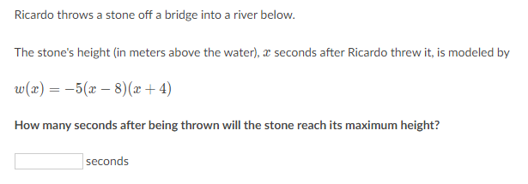
Solutions to Example 1:
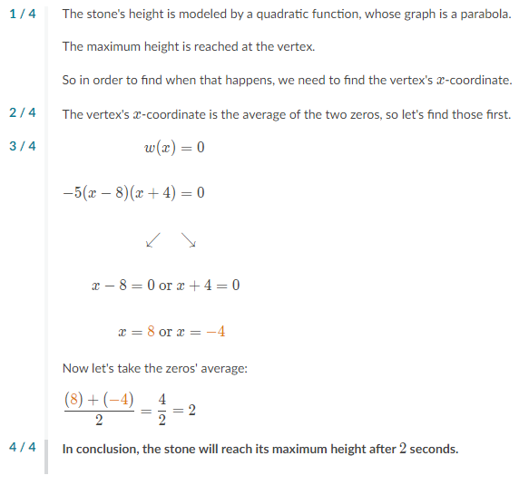
- Example 2
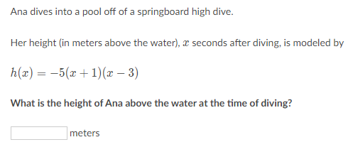

Solutions to Example 2:
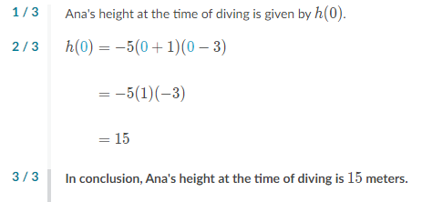

Note: The question asks for the height at the time of diving. We don’t know the height, but we do know the time at which Ana dives (time = 0 seconds). Plug zero into the function: h(0).

- Example 3
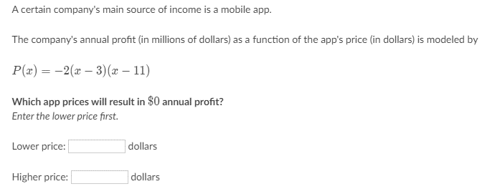
Solutions to Example 3:
