Linear Equations Word Problems
- Example 1
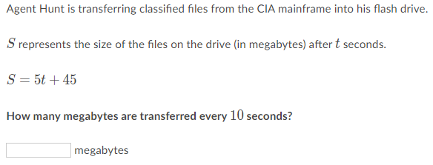

Solutions to Example 1:
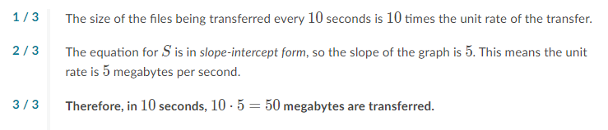

- Example 2
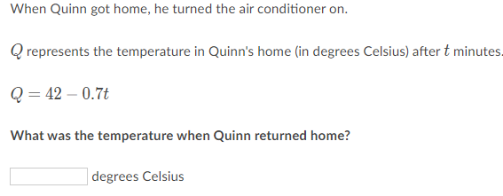
Solutions to Example 2:
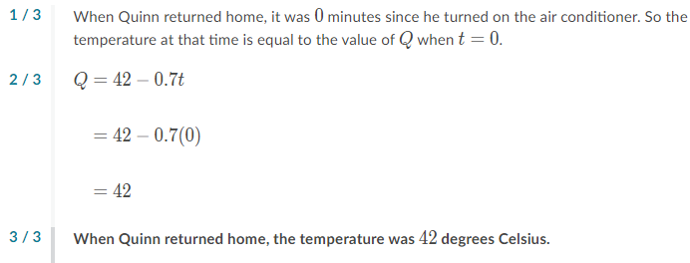

- Example 3
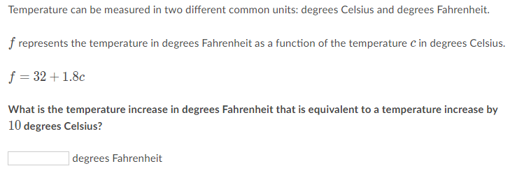

Solutions to Example 3: 